**2014 OK Dinghy World Championship, Black Rock Yacht Club, Melbourne, Australia**

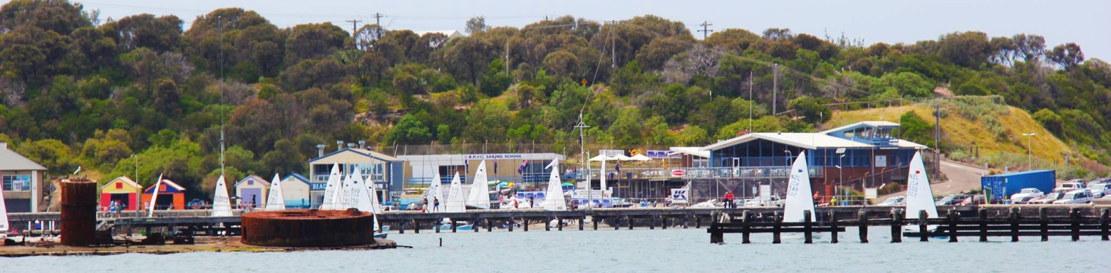

**Accommodation**

There are a range of accommodation options available and there will be the opportunity of billeting with local club members. Details can be found on the OK Dinghy Words 2014 web site.

**[www.okworlds2014.com](http://www.okworlds2014.com/)**

**Charter Boats**

We are also working on getting as many quality charter boats available, please visit the OK Dinghy Worlds 2014 web site to register your interest

You are cordially invited to the 2014 OK Dinghy World Championship by the National OK Association of Australia and the Black Rock Yacht Club, to be conducted on the waters of Port Phillip from  
Friday 26th December, 2014 to Sunday 4th January, 2015.

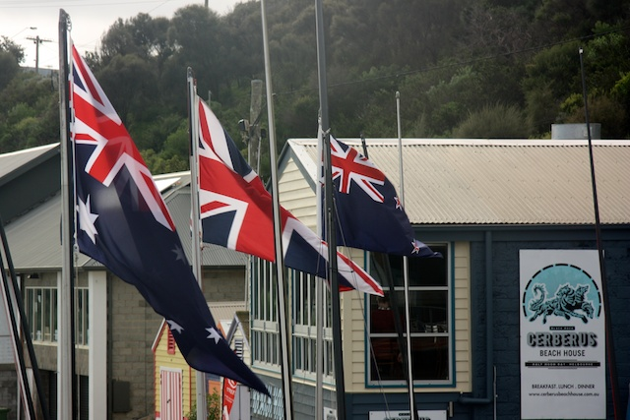

**Preliminary Program**

Friday 26 Dec 2014: Pre Worlds racing  
Sat 27 Dec: registration, measurement, pre worlds racing  
Sun 28 Dec: registration, meas., Official Welcome Function  
Mon 29 Dec: registration, measurement, Invitation race  
Tue 30 Dec: Racing  
Wed 31 Dec: racing and New Years Eve function  
Thu Jan 1 2015: Lay Day  
Fri Jan 2: Racing  
Sat Jan 3: Racing  
Sun Jan 4: Racing and Official Presentation function

**About the venue**

Established in 1904 the club has a history of first class performance in 'off the beach' competitions as well as a reputation unsurpassed in the staging of world class events. World Championships are regularly conducted at the club including the OK Worlds (1982 and 1990) and the Finn Gold Cup (1995, 1999, 2008).

Situated in the picturesque Half Moon Bay there is a sheltered beach that is ideal for families to relax in the sun. The Beach House Cafe offers both fine dining and take away fish and chips.

**Attractions**

Black Rock is situated just a 20 minute train ride from the heart of Melbourne which is the cultural and sporting capital of Australia. There is something to appeal to all age groups and families from music, theatre, fashion, shopping and galleries and museums. Getting around is easy using the iconic Melbourne trams.  
To experience the great Australian wildlife the Healesville Sanctuary is 90 minutes away and packed with kangaroos, koalas, platypus and unique birds.

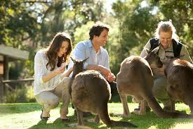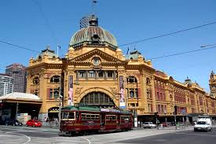

Visit the tourism website to see what Melbourne and Victoria can offer you and your family;

**www.visitvictoria.com**